BANK LOAN REPORT QUERY DOCUMENT
- BANK LOAN REPORT | SUMMARY
KPI’s:
Total Loan Applications
SELECT COUNT(id) AS Total_Loan_Applications FROM bank_loan
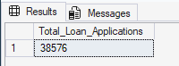
MTD Loan Applications
SELECT COUNT(id) AS MTD_Total_Loan_Applications FROM bank_loan
WHERE MONTH(issue_date) = 12
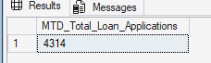
PMTD Loan Applications
SELECT COUNT(id) AS PMTD_Total_Loan_Applications FROM bank_loan

WHERE MONTH(issue_date) = 11
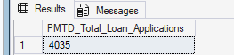

Total Funded Amount
SELECT SUM(loan_amount) AS Total_Funded_Amount FROM bank_loan
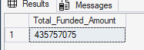
MTD Total Funded Amount
SELECT SUM(loan_amount) AS MTD_Total_Funded_Amount FROM bank_loan
WHERE MONTH(issue_date) = 12
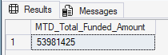

PMTD Total Funded Amount
SELECT SUM(loan_amount) AS PMTD_Total_Funded_Amount FROM bank_loan
WHERE MONTH(issue_date) = 11
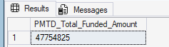

Total Amount Received
SELECT SUM(total_payment) AS Total_Amount_Collected FROM bank_loan
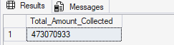
MTD Total Amount Received
SELECT SUM(total_payment) AS MTD_Total_Amount_Collected FROM bank_loan
WHERE MONTH(issue_date) = 12
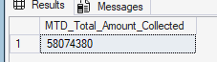
PMTD Total Amount Received
SELECT SUM(total_payment) AS PMTD_Total_Amount_Collected FROM bank_loan
WHERE MONTH(issue_date) = 11
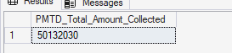

Average Interest Rate
SELECT AVG(int_rate)*100 AS Avg_Int_Rate FROM bank_loan
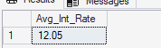
MTD Average Interest
SELECT AVG(int_rate)*100 AS MTD_Avg_Int_Rate FROM bank_loan
WHERE MONTH(issue_date) = 12
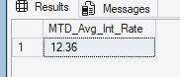

PMTD Average Interest
SELECT AVG(int_rate)*100 AS PMTD_Avg_Int_Rate FROM bank_loan
WHERE MONTH(issue_date) = 11
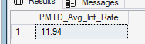

Avg DTI
SELECT AVG(dti)*100 AS Avg_DTI FROM bank_loan
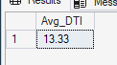
MTD Avg DTI
SELECT AVG(dti)*100 AS MTD_Avg_DTI FROM bank_loan
WHERE MONTH(issue_date) = 12
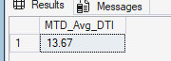
PMTD Avg DTI
SELECT AVG(dti)*100 AS PMTD_Avg_DTI FROM bank_loan
WHERE MONTH(issue_date) = 11
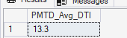

GOOD LOAN ISSUED
Good Loan Percentage
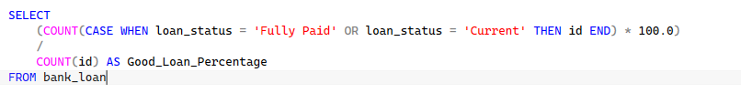
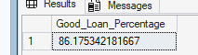

Good Loan Applications
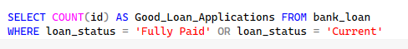
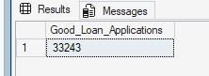
Good Loan Funded Amount
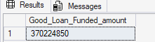
Good Loan Amount Received
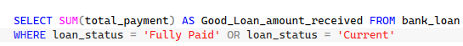
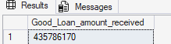

BAD LOAN ISSUED
Bad Loan Percentage
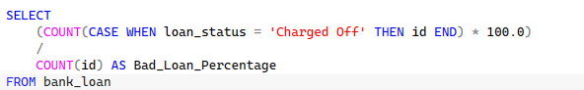
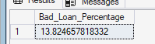

Bad Loan Applications
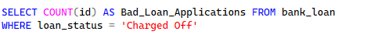
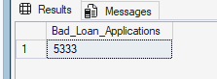
Bad Loan Funded Amount
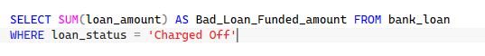
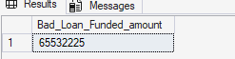
Bad Loan Amount Received
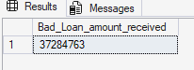

LOAN STATUS
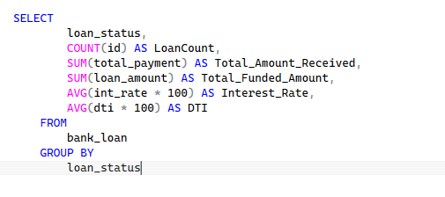
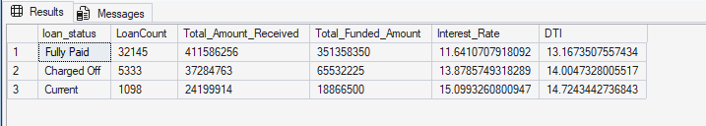

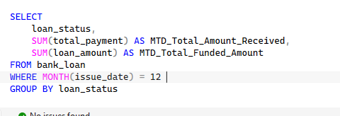
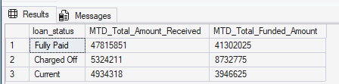

- BANK LOAN REPORT | OVERVIEW
MONTH
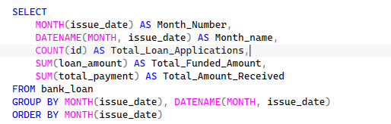
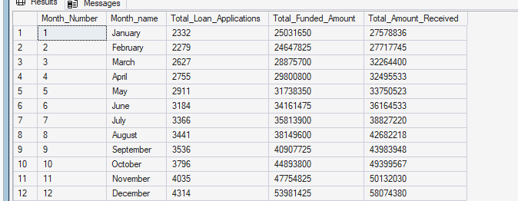

STATE
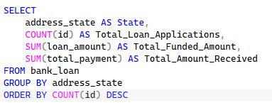
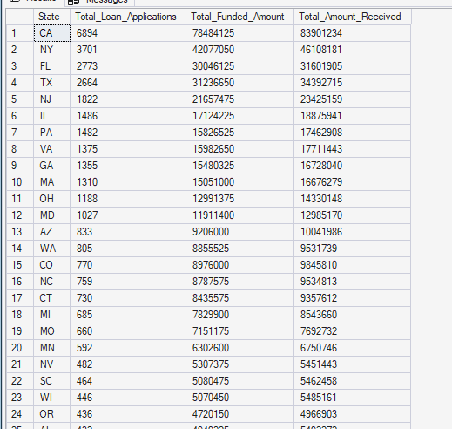

TERM
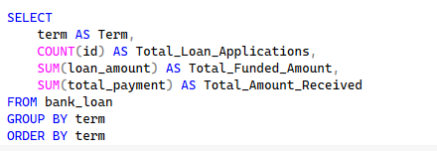
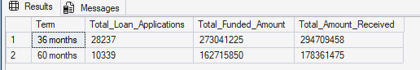
EMPLOYEE LENGTH
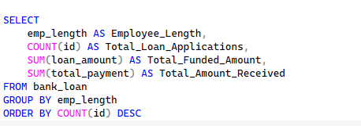
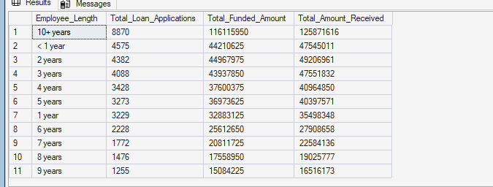

PURPOSE
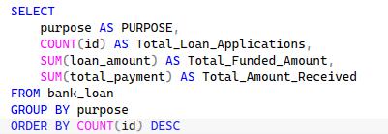
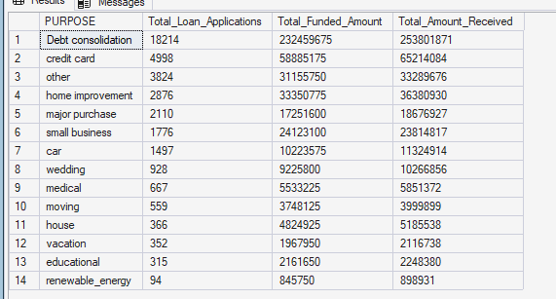
HOME OWNERSHIP
